CPU

First :

***Computer processors (CPUs)***

* Definition: A processor is the logic circuitry that responds to and processes the basic instructions that drive a computer.
* Another name of processor is central processing unit (CPU)
* We can consider it as the brain of the computer as every action the computer performs passes through the cpu.
* processors are the most significant contributor to computer performance and speed.
* The two leading CPU manufacturers are AMD and Intel
* An image of a cpu :<https://assetsio.gnwcdn.com/intel_reveals_11th_gen_desktop_processors_1615895380709.jpg?width=690&quality=70&format=jpg&dpr=2&auto=webp>
* There is an intel processor:

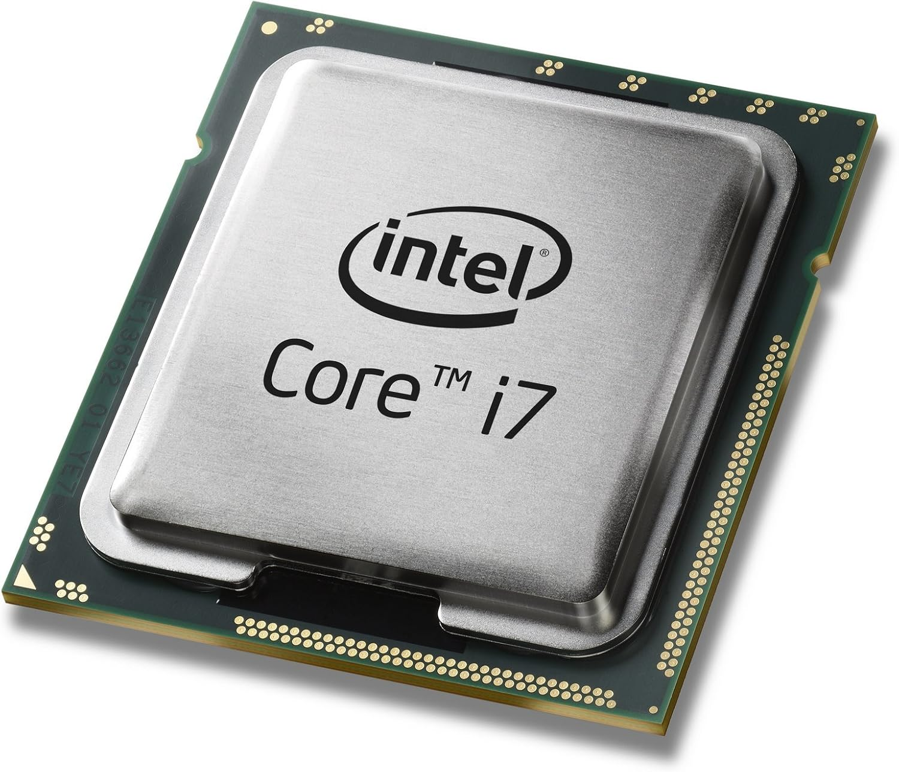

* **Main Components of a CPU:**

**- ALU (Arithmetic Logic Unit)** – Performs arithmetic and logical operations.

- **CU (Control Unit)** – Directs the operation of the processor by telling the computer's memory, ALU, and input/output devices how to respond to instructions.

- **Registers** – Small, fast memory locations inside the CPU used to store data temporarily.

* **Measuring processors:**

- CPUs are measured in the maximum number of instruction cycles they can perform **per second.**

- To measure frequency per second we use **hertz** .Modern CPUs are measured in gigahertz (GHz). One gigahertz is equivalent to **1 billion instructions per second**

**-Cores:** a single processing unit within the CPU that can execute instructions. More cores allow more tasks to be processed simultaneously.

- CPU speed: is a measure of how many cycles a CPU can execute per second.

Example: a CPU with a clock speed of 3 GHz can process 3 billion cycles per second.

-**CPU**: Intel Core i5, 3.1 GHz, Quad-core

* **Types of CPUs:**

**-Desktop CPUs** (e.g., Intel Core, AMD Ryzen). the core element of every computer. It is the decisive factor in the overall speed of your PC and controls all basic computational tasks, such as supplying the graphics card with data.

-**Mobile CPUs** (used in laptops, smartphones; e.g., Apple M-series, Snapdragon).

-**Server CPUs** (e.g., AMD EPYC, Intel Xeon). has a critical part to play in the performance of a system. All instructions and commands are handled through the processor, which acts as a relay for all incoming and outgoing data

-**Embedded CPUs** (used in IoT devices, appliances).a central processing unit built into an embedded system that controls the system's basic functions. Embedded processors are a type of microprocessor and usually have limited functions. Often, they use minimal power

GPU

Second:

**Graphics processing unit (GPU)**

* A **GPU (Graphics Processing Unit)** handles **graphics,** images**, and lots of small tasks at once**.
* **GPU is great for gaming ,AI,video ,science**
* **Made for parallel tasks and visual powe**
* **GPU uses:**

- Renders images and videos — (shows pictures, animations, and 3D graphics.)

- Accelerates gaming performance —( gives smoother and faster graphics.)

- Speeds up video editing — (makes editing faster and smoother.)

- Helps in AI and machine learning —( trains models much faster.)

- Used in data science —( processes lots of data at once.)

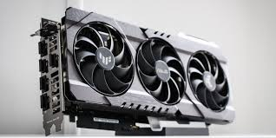

* Image of a GPU:
* **GPU**: NVIDIA GTX 1660, 6 GB VRAM
* Types of GPU:

**Integrated GPU:**

Built into the CPU.

Uses system memory

Good for basic tasks (browsing, watching videos).

**Dedicated GPU**:

Separate from the CPU

Has its own memory .

More powerful – good for gaming, AI, editing.

* **KEY PARTS of a GPU:**

Cores: Thousands of tiny processors for multitasking.

VRAM (Video RAM): Stores graphics and textures.

Shaders: Create visual effects.

Cooling system: Keeps it from overheating.

* **Popular GPU brands:(** NVIDIA,AMD ,INTEL)

CPU VS GPU

**CPU VS GPU**

**CPU:**

* **Main brain of the computer.**
* **Handles all types of tasks (running apps, browsing, etc.).**
* **Good at doing a few things really fast.**
* **Has a few powerful cores.**

**GPU:**

* **Helper brain for handling graphics and big data tasks.**
* **Made to do many things at once, but simpler tasks.**
* **Has thousands of small cores.**
* **Great for gaming, video editing, and AI.**

**CONCLUSION;**

* **CPU : Good at everything, but slower at multitasking.**
* **GPU : Great at multitasking, but only for certain jobs.**

| **Feature** | **CPU** | **GPU** |
| --- | --- | --- |
| JOB TYPE | General tasks | Graphics & parallel tasks |
| cores | Few (4–16 powerful cores) | Many (hundreds to thousands) |
| strength | Fast at single tasks | Fast at many tasks at once |
| Used for | Running apps, OS, basic computing | Gaming, video, AI, big data |

motherboard

**Fourth:**

**Motherboard**

* The **motherboard** is the **main circuit board** in a computer. It connects **all parts of the computer together**, like the **CPU, RAM, storage, GPU**, and other components.
* The motherboard connects everything in your computer.
* It decides what parts you can use (CPU type, RAM size, etc.).
* A good motherboard gives better performance, more ports, and upgrade options
* **Uses of a motherboard:**

-Connects and powers the CPU, RAM, storage (SSD/HDD), GPU, and cooling systems.

-parts to communicate with each other.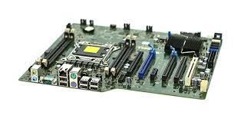

-Provides ports for USB, HDMI, audio, and internet.

-Controls how data moves inside the computer.

* **Main Parts of a Motherboard:**

**-**CPU socket : it holds the CPU.

-RAM slots: they are where memory installed

- PCIE slots: they are for graphics, wifi cards , etc…

-SATA/M.2 ports: it connect SSDs andHHDs

-chipset: it helps how components communicate

-power connectors: it supply electricity to the board and components

-I/O ports: USB,HDMI,audio, LAN ports

* **Types of motherboards:**

| **TYPE** | **SIZE** | **USE** |
| --- | --- | --- |
| **ATX** | **standard** | **Full-sized desktops** |
| **Micro-ATX** | **smaller** | **Mid-sized PCs** |
| **Mini-ITX** | **Very small** | **Compact and mini PCs** |

* **This is an** [**image of a motherboard**](https://www.dfi.com/Uploads/Product/b7783464-f401-4bb0-b065-6e3ee4ea9a27/ARS630%20R1(F250115)_w600.png?timestamp=1737397637.74789)
* **This is an image indicates the components of a computer**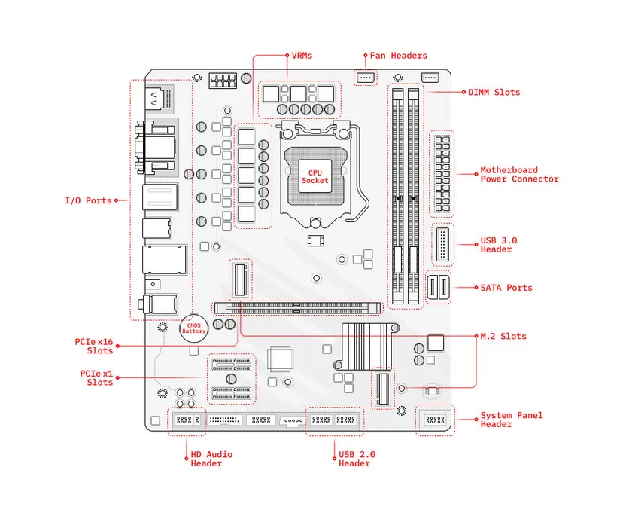

**THANK YOU .**

memory

Third:

**Computer memory**

* **Memory** is where a computer **stores data**. It helps the computer **run programs and remember information**, either **temporarily** or **permanently**.
* **Types of computer memory:**

1. **Primary Memory ( Main Memory):Used while the computer is working. Fast, but temporary.**

**Types of main memory:RAM:(random access memory) Stores data while programs are running. Gets cleared when the computer turns off means More RAM = faster multitasking. RAM: 16 GB DDR4, 3200 MHz**

**ROM:(read -only memory) Stores permanent data. You can’t change it easily.**

1. **Secondary Memory ( Storage):Used to store data permanently.**

| **Type** | **Description** |
| --- | --- |
| **HDD (Hard Disk Drive)** | **Stores lots of data. Slower, but cheaper. Has moving parts .Hard Drive: 1 TB HDD, 7200 RPM** |
| **SSD (Solid State Drive)** | **Faster than HDD, no moving parts, more expensive .SSD: 512 GB NVMe** |
| **USB/Memory Card** | **Portable storage devices using flash memory.** |

1. **Cache memory:**

**-Very fast memory inside the CPU.  
-Stores frequently used data for quick acces**

**-Helps the CPU work faster.  
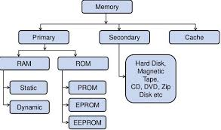**

* **An image for a computer memory**

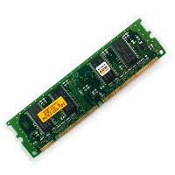

* **An image for different types of computer memory**[**https://computerguideonline.com/images/types-of-computer-memory.webp**](https://computerguideonline.com/images/types-of-computer-memory.webp)
* **NOTES:**

**-** More RAM = Better multitasking and faster apps.

-SSD is faster than HDD.  
-Cache is the fastest, but smallest.

-ROM is not erased; RAM is temporary.

### **Memory vs Storage :**

-Memory (RAM) = Short-term, fast, cleared when off.  
-Storage (HDD/SSD) = Long-term, where files and apps live.